## Creating a chatbot and chatbot instance ( in IBM PRA SaaS installation).

**Requirements**

Licenses required to deploy a chatbot script.

| **License** | **Minimum required** |
| --- | --- |
| Bot Runtime | 1 |

You need at least one Bot Runtime license for each chatbot script. Go to the [License page](https://www.ibm.com/docs/en/SSTHBP_21.0/using_ibm_rpa/digital_assistant/deploy/deploy_chat/saas/%60https:/localhost:8099/web/en-US/license%60)  - [IBM RPA Client](https://localhost:8099/web/en-US/ibmrpaclient)- /https://localhost8099/web/en-US/ ibmrpaclient/on the machine where IBM RPA was installed to view license data.

**Steps**

1. Develop chatbot script /WAL file/ ready to deploy. We could use a Knowledge base KB (excel table with certain structure), in witch we can pre-define answers or questions from expected users’ responses. KB might be previous filled or on a later stage it may be trained directly in WDG Automation Studio with the tool – Knowledge base training.
2. After creating the KB, it must be published inIBM RPA Control Center trough Machine learning Model Builder tool in WDG Studio.
3. Configure the computer credential to make sure that the bot can access the Bot Runtime computer:

* Log in to your tenant in the IBM RPA Control Center.
* From the **Define** menu, click **Credentials** > **Credentials** tab.
* Choose one of the following actions:
  1. To create a new credential: click **New Credential**.
  2. To edit an existing credential: click **⋮** > **Edit**
* Enter the data:
  1. In the **Name** field, enter the credential name.
  2. In the **Username** field, enter the computer credential username.
  3. In the **Password** field, enter the computer credential password.
* From the **Define** menu, click **Computers** > **⋮** > **Edit** a computer.
  1. In the **Credential** field, select the credential name.

1. Creating a Chatbot instance -To debug a chatbot script in IBM Robotic Process Automation (IBM RPA) Studio and integrate the chatbot with communication channels such as Web Chat, Kik, Telegram, Microsoft Teams, Facebook, and Slack, you need to have a chatbot instance created in IBM RPA control center and in the Azure portal environment (only for IBM RPA on-premises) or order your chatbot instance from IBM Support. In our case (SaaS IBM RPA) we need to order **instance from IBM Support to deploy our script**. A chatbot instance is a unique object that holds the data to deploy chatbot scripts in communication channels. The Web Chat, a customizable web page in which you chat with a chatbot, is the default communication channel. The procedure is following:

* Navigate to [IBM Support 🡥](https://www.ibm.com/mysupport/s/?language=en_US" \t "_blank).
* Click **Open a case**. In your support case, you need to attach:
  1. IBM RPA Control Center tenant name.
  2. IBM RPA tenant's region, for example, AP1(**eu1 in our case**).
  3. Chatbot name (or bot handle). The chatbot name must be unique, provide at least three options of names.
* Wait until the IBM support confirms the chatbot instance creation.
* **The automation script (WAL) that uses bot commands to implement a chat dialog as part of the automation is currently exposed using MS Azure Bot Service. This is something that WDG/IBM support need to do for us.  Once they have created the service for us, they will also map the service to our WDG tenant. Then it appears as a "bot" that we can use to make a Chat Mapping, where we actually tie together the Azure Bot Service created for us and the automation script we developed and published to our tenant. When doing the chat mapping, we can also define the computer(s) / runtime(s) responsible to run our automation script when ever our exposed script is triggered.**

After the creation is done, you can view the chatbot instance in the [Chat mappings](https://www.ibm.com/docs/en/SSTHBP_21.0/using_ibm_rpa/digital_assistant/deploy/deploy_chat/chat_mapping.html) on the IBM RPA Control Center. The following image shows an example of how the chatbot instance named ibm-dsystems-bot appears in mapping.

An example of how the chatbot instance named ibm-dsystems-bot appears in a mapping.

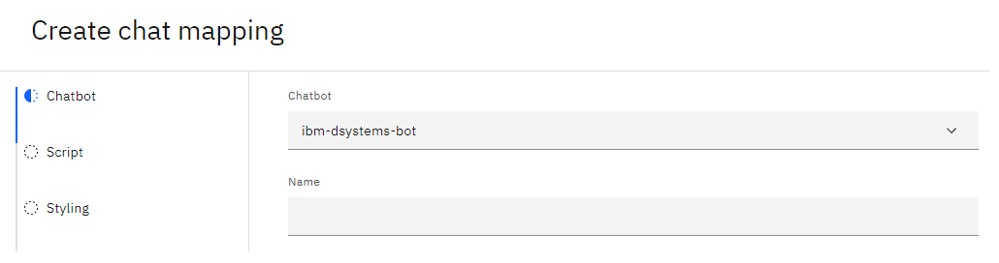

1. Creating a chatbot mapping - create a chat mapping to configure all the features a chatbot needs to run on a communication channel.

We need to **follow the below** mentioned procedure:

Follow the steps below to configure all the needed features for a chatbot to run in chat mapping.

* Log in to IBM RPA control center.
* In the side menu, click **Chatbots** > **Chats Mappings**.
* Choose the desired action:
* To create a new chat map: click **Create chat mapping**.
* If you choose to edit an existing chat mapping: Click the vertical ellipsis button > **Edit Chat Mapping**.

When creating a chat mapping, you need to configure three steps, namely:

* Bot
* Script
* Styling

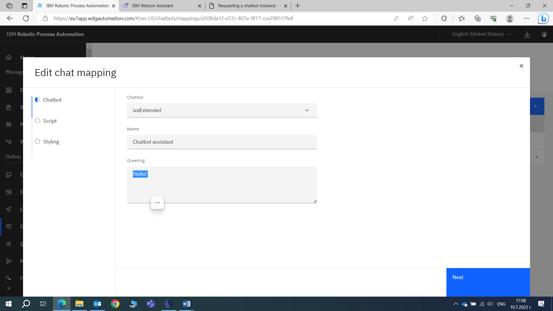

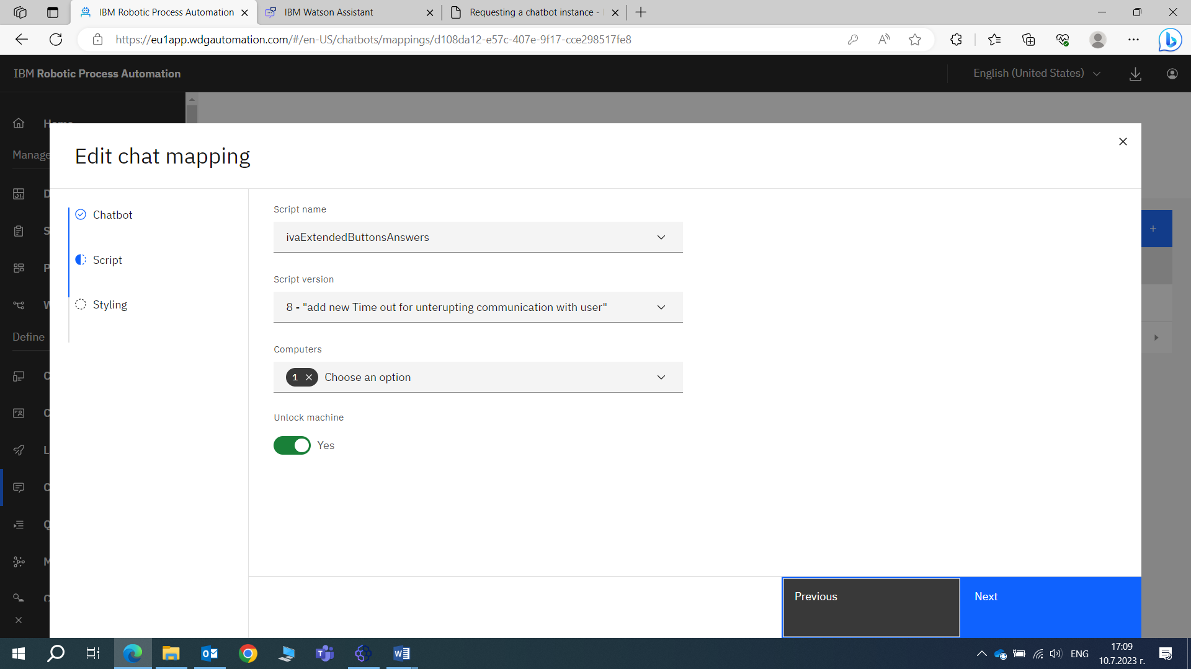

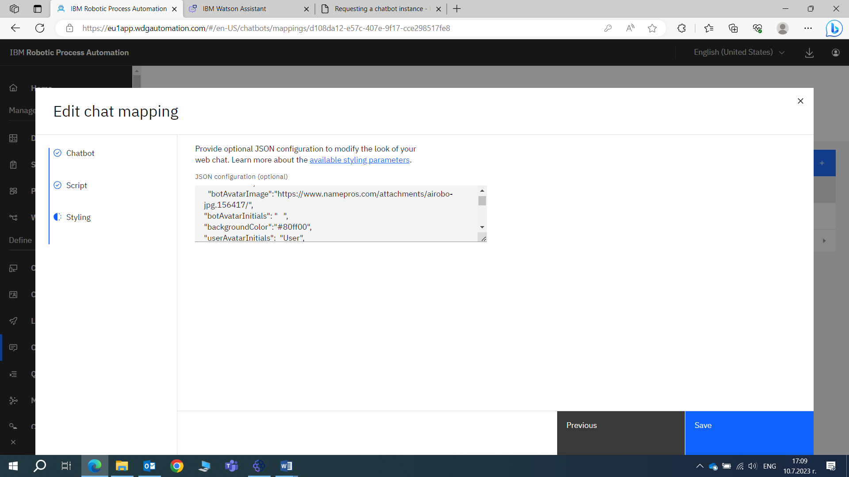

On this stage the main exterior layout can be modified. There are possibilities for applying custom stiles to out chatbot. You can apply custom styles to your chatbot to change its default appearance. Custom styling is only possible for the default web chat view of the chatbot (Direct Line web chat). In the **Styling** step when creating or editing a [chat mapping](https://www.ibm.com/docs/en/SSTHBP_21.0/using_ibm_rpa/digital_assistant/deploy/deploy_chat/chat_mapping.html), the **JSON configuration** field accepts JSON data containing the custom styles. You can use one or more of the attributes described in the [JSON attributes](https://www.ibm.com/docs/en/rpa/21.0?topic=saas-applying-custom-styles-your-chatbot" \l "json-attributes) section.

**Note:** Some of the attributes have default values. You can review these values in the **Web Chat customization** documentation on Microsoft's official documentation for Bot Framework SDK 4.

## After creating the chatbot instance and the chat mapping, your chatbot script is ready to chat.

**6.** Integrating the bot with communication channels - communication channels are the media where the user and the chatbot interact with each other. The way to interact with an IBM RPA chatbot is by running the script in debug mode in IBM RPA Studio or using a communication channel.

The available channels for chatbot integration are:

* Web Chat
* Kik
* Telegram
* Microsoft Teams
* Facebook
* Slack
* Other

### Note: Each communication channels have different data to integrate with the IBM RPA Chatbot.

Below mentioned links refer to the following topics for the prerequisites and instructions to request chatbot integrations:

* [Requesting a bot integration with the Telegram channel](https://www.ibm.com/docs/en/SSTHBP_21.0/using_ibm_rpa/digital_assistant/deploy/deploy_chat/saas/saas_request_bot_telegram.html)  
  Learn how to request a chatbot integration with the Telegram™ channel.
* [Requesting a bot integration with the Microsoft Teams channel](https://www.ibm.com/docs/en/SSTHBP_21.0/using_ibm_rpa/digital_assistant/deploy/deploy_chat/saas/saas_request_bot_microsoft.html)  
  Learn how to request a chatbot integration with the Microsoft™ Teams channel.
* [Requesting a bot integration with the Facebook channel](https://www.ibm.com/docs/en/SSTHBP_21.0/using_ibm_rpa/digital_assistant/deploy/deploy_chat/saas/saas_request_bot_facebook.html)  
  Learn how to request a chatbot integration with the Facebook™ channel
* [Requesting a bot integration with the Slack channel](https://www.ibm.com/docs/en/SSTHBP_21.0/using_ibm_rpa/digital_assistant/deploy/deploy_chat/saas/saas_request_bot_slack.html)  
  Learn how to request a chatbot integration with the Slack™ channel.
* [Requesting a bot integration with the Twilio channel](https://www.ibm.com/docs/en/SSTHBP_21.0/using_ibm_rpa/digital_assistant/deploy/deploy_chat/saas/saas_request_bot_twilio.html)  
  Learn how to request a chatbot integration with the Twilio™ channel.
* [Requesting a bot integration with the LINE channel](https://www.ibm.com/docs/en/SSTHBP_21.0/using_ibm_rpa/digital_assistant/deploy/deploy_chat/saas/saas_request_bot_line.html)  
  Learn how to request a chatbot integration with the LINE™ channel.

#### **7.** Navigating to Web Chat

The Web Chat channel is the default communication channel. You can interact with chatbot directly on a web page using the Web Chat channel.

#### Procedure for accessing the chatbot:

* Navigate to the URL: https://<REGION>bot.wdgautomation.com/integration/<BOTHANDLE>.
* Enter the IBM RPA tenant region where is <REGION>.
* Enter the bot handle where is <BOTHANDL>. Use the same bot handle you use to create your chatbot instance.

**(https://eu1bot.wdgautomation.com/integration/ivaExtended)**

See [Tenant regions](https://www.ibm.com/docs/en/SSTHBP_21.0/web_client/tenant/tenant.html#tenant-regions) to learn more about IBM RPA tenant's region- in our case **eu1**

## Results

You can use the Web Chat channel to chat with the IBM RPA chatbot.

## What to do next

Follow the procedures if you receive the message, "Sorry, looks like I won’t be able to answer you now, try later."

* Navigate to https://<REGION>bot.wdgautomation.com/api/status/<BOTHANDLE> to verify the Bot API status.
* Check if you have Bot Runtime licenses available. Your bot uses one Bot Runtime license for each user interacting in the chat. See [License page](https://www.ibm.com/docs/en/SSTHBP_21.0/using_ibm_rpa/digital_assistant/deploy/deploy_chat/saas/%60https:/localhost:8099/web/en-US/license%60) for more information.
* Check in the <online> XML tag if the computer entered in the chat mapping is online -**https://eu1bot.wdgautomation.com/api/status/ivaExtended**
* Open a case in the [IBM Support](https://www.ibm.com/mysupport/s/?language=en_US) if your bot did not work.

**8.** Integrating a chatbot into web page or web APP - exposing can be done to your own web application or web page, using the exposed URL or it can be integrated to several different channel applications (Slack, Facebook, Teams, etc.) using the Azure Bot service configurations. So, if you need your chatbot connected to a certain channel app, you need to provide the connections details to WDG/IBM support when they configure the Azure Bot Service for you.

When it comes to integrating into web page we need to embed a pre-defined link (for example - https://eu1bot.wdgautomation.com/api/status/ivaExtended) in to desired web page.

The follow simple HTML code demonstrate how we can do this task:

<html>

<head></head>

<body>

<title>My Test Page</title>

<p>The body of my page.</p>

<iframe src='https://eu1bot.wdgautomation.com/integration/ivaExtended' style='min-width: 300px; width: 30%;height:60%; min-height: 38px;'></iframe>

</body>

</html>

Our bot links is embedded in to iframe with certain dimensions.

But if we want to accomplish more professional result we should complicate out work applying additional Java Script code :

<!DOCTYPE html>

<html lang="en">

<head>

<meta charset="UTF-8">

<meta name="viewport" content="width=device-width, initial-scale=1.0">

<title>Document</title>

</head>

<body>

</body>

<script>

(function () {

var div = document.createElement("div");

document.getElementsByTagName('body')[0].appendChild(div);

div.outerHTML = "<div id='botDiv' style='height: 38px; position: fixed;; bottom: 0;margin-left:350px; z-index: 1000; background-color: #fff'><div id='botTitleBar' style='height: 38px; width: 400px; position:fixed; cursor: pointer;'></div><iframe width='400px' height='600px' src='https://eu1bot.wdgautomation.com/integration/ivaExtended'></iframe></div>";

document.querySelector('body').addEventListener('click', function (e) {

e.target.matches = e.target.matches || e.target.msMatchesSelector;

if (e.target.matches('#botTitleBar')) {

var botDiv = document.querySelector('#botDiv');

botDiv.style.height = botDiv.style.height == '600px' ? '38px' : '600px';

};

});

}());

</script>

</html>

In this way we have created separated chatbot element on our web page.

If we keep going on with JS and CSS layout, may improve more the visual style or visual appearance of our chatbot. We can change the form, to insert buttons, to set various timeouts and e.g.

For testing purpose above JS codes should be inserted in new text document and save it as .html format.